PRACTICAL -09
Aim:
To write a program to implement Prim’s Algorithm for finding the Minimum Spanning Tree of a graph.
Theory:
A Spanning Tree of a connected, undirected, weighted graph is a subgraph that includes all the vertices and is a tree (connected and with no cycles), using exactly V – 1 edges. A Minimum Spanning Tree (MST) is the spanning tree whose total edge weight is as small as possible. MSTs are used in network design, such as laying cables, pipelines or roads at minimum cost.
Prim’s Algorithm is a greedy algorithm that builds the MST one vertex at a time. It starts from an arbitrary vertex and repeatedly adds the cheapest edge that connects a vertex already in the tree to a vertex outside the tree. This works because of the cut property: for any partition of the vertices into two sets, the minimum-weight edge crossing the partition belongs to some MST. At each step there are two cases for a vertex taken from the priority queue:
- Already in the tree: the edge would form a cycle, so it is skipped.
- Not yet in the tree: the vertex and its edge are added to the MST, and all edges from it to unvisited vertices are pushed into the priority queue.
A min-heap (priority queue) is used to always pick the smallest available edge quickly. With an adjacency list and a binary heap, Prim’s algorithm runs in O(E log V) time; with an adjacency matrix and no heap it takes O(V²).
Algorithm:
- Input the graph as an adjacency list with edge weights, and choose a starting vertex.
- Create a visited array (all False) and an empty MST edge list; insert (0, none, start) into a min-heap.
- While the heap is not empty:
  - Remove the entry with the smallest weight, (weight, u, v).
  - If v is already visited, skip it.
  - Otherwise, mark v as visited; if u exists, add the edge (u, v) to the MST and add its weight to the total cost.
  - For every neighbour of v that is not visited, push (edge weight, v, neighbour) into the heap.
- When the heap is empty, the MST contains V – 1 edges.
- Display the MST edges and the total cost.
Program Code:
import heapq

def prim(graph, start=0):
n = len(graph)
visited = [False] * n
mst_edges = []
total_cost = 0

# min-heap of (weight, from_vertex, to_vertex)
heap = [(0, -1, start)]

while heap:
weight, u, v = heapq.heappop(heap)
if visited[v]:
continue
visited[v] = True
if u != -1:
mst_edges.append((u, v, weight))
total_cost += weight
for neighbour, w in graph[v]:
if not visited[neighbour]:
heapq.heappush(heap, (w, v, neighbour))

return mst_edges, total_cost

# Demo
if __name__ == "__main__":
n = 6
graph = {i: [] for i in range(n)}
edges = [(0, 1, 4), (0, 2, 4), (1, 2, 2), (1, 3, 5),
(2, 3, 8), (2, 4, 10), (3, 4, 2), (3, 5, 6), (4, 5, 3)]
for u, v, w in edges:
graph[u].append((v, w))
graph[v].append((u, w))

mst, cost = prim(graph, 0)
print("Edges in the Minimum Spanning Tree:")
for u, v, w in mst:
print(u, "-", v, ": weight", w)
print("Total cost of MST:", cost)

Output:
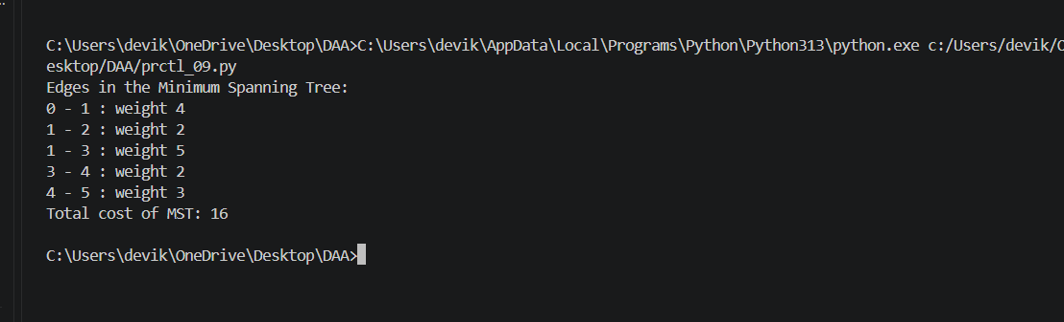

Result:
The program successfully implements Prim’s Algorithm. Starting from vertex 0, it greedily selects the cheapest edge connecting the tree to a new vertex and produces a Minimum Spanning Tree of 5 edges with a total cost of 16 for the given graph, running in O(E log V) time.

